Angel Velazquez

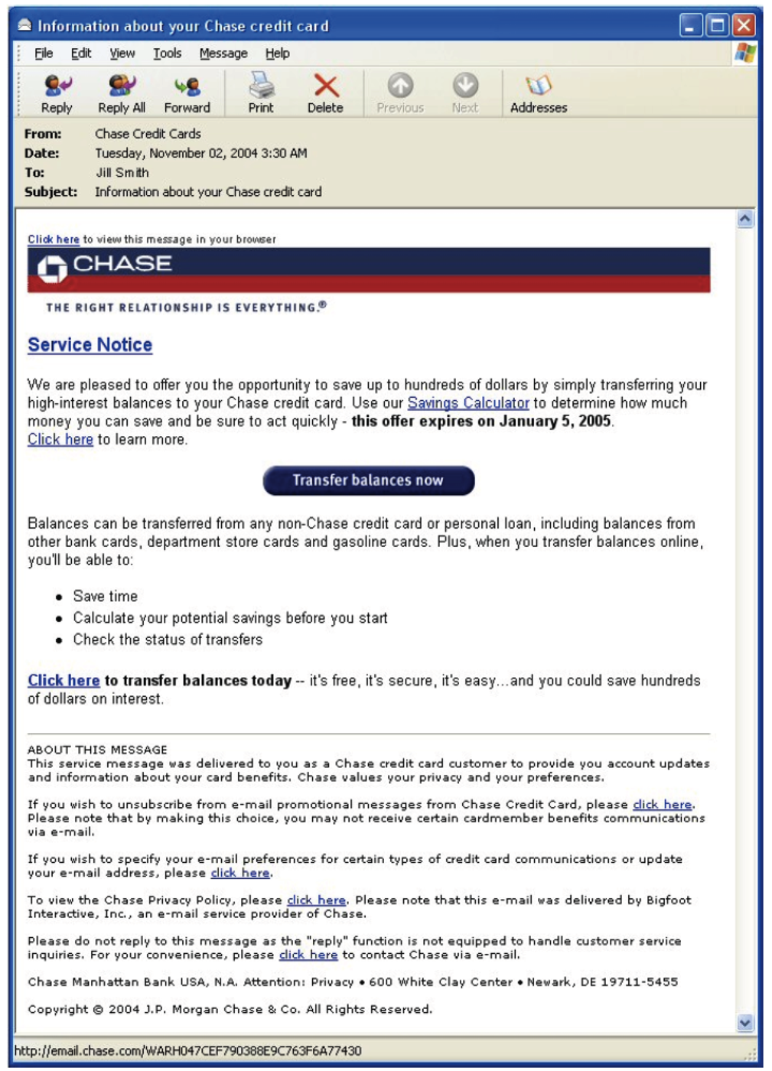

1. This phish is based on vague information stating that the user can win “hundreds” of dollars. Additionally, the link posted that directs to the balance transfer indicates that this email is probably a scam.

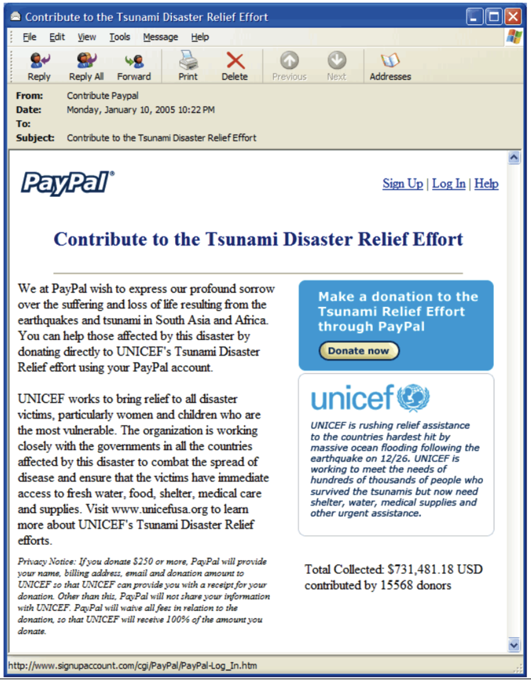

1. This is a real email.

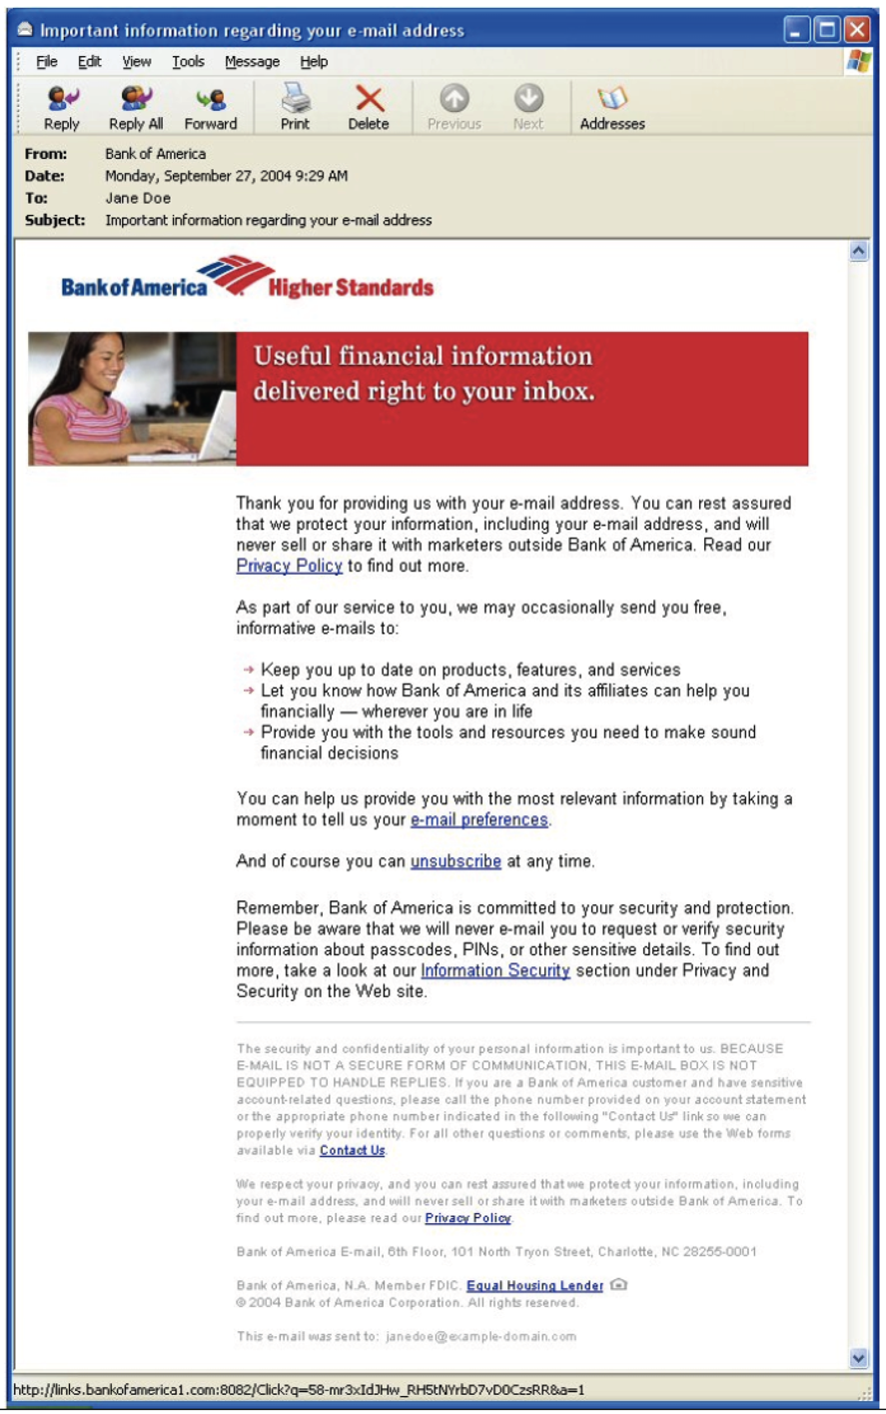

1. This email is real. No typos are present, and reminders of sharing personal information are present.

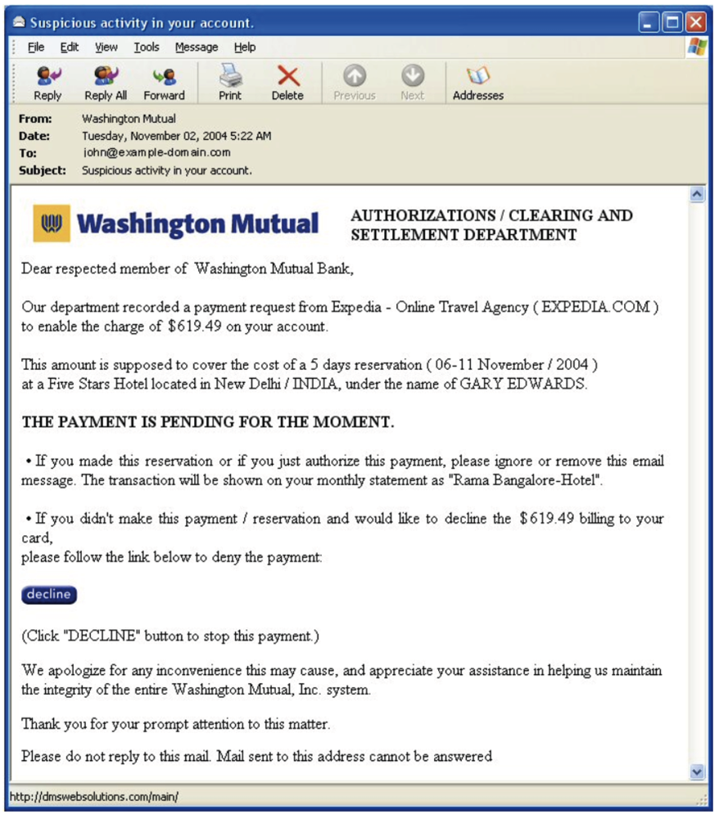

1. This email is a phish because banks do not know the specifics of purchases; they can only see where the transactions were made.

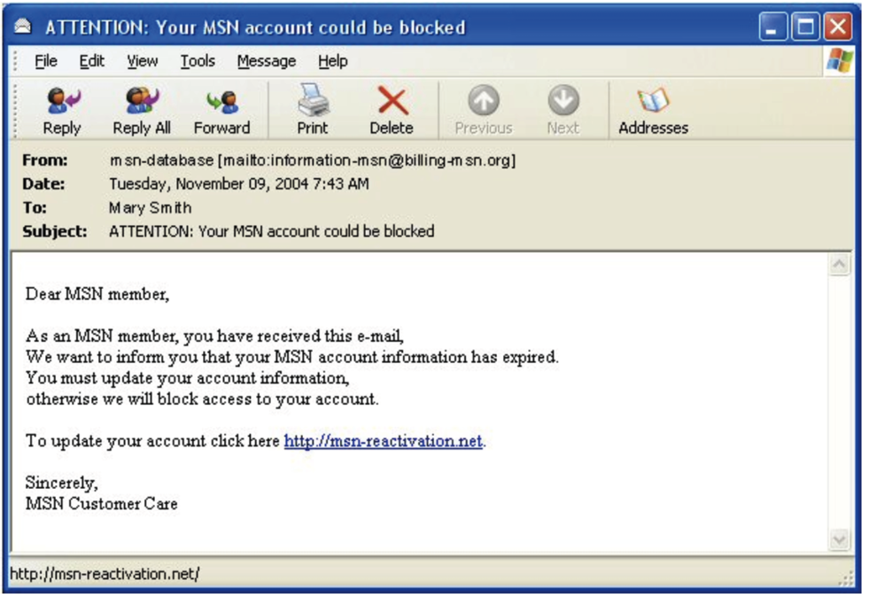

1. This email is a phish because the language presented in the email is not professional to current standards. “Otherwise, we will block access to your account” sounds like a threat.

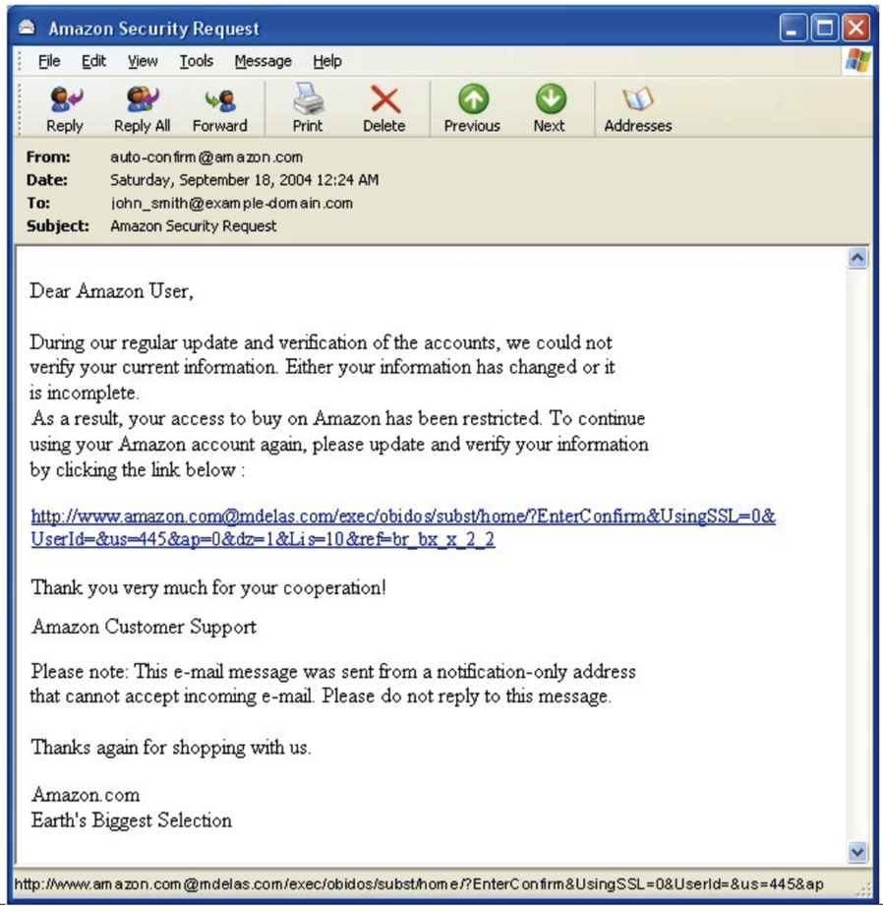

1. This is a phish because the footer is “Earth's Biggest Selection.” This should not be in the signature.

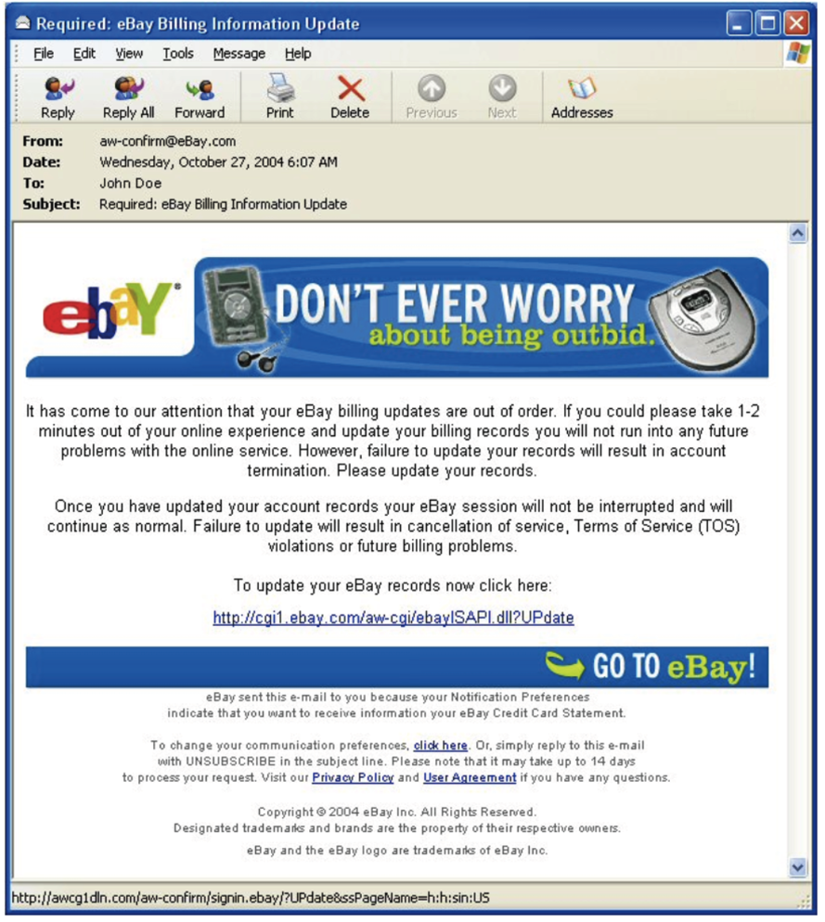

1. This email appears real; however, the link is not the real eBay website link. This is a phish

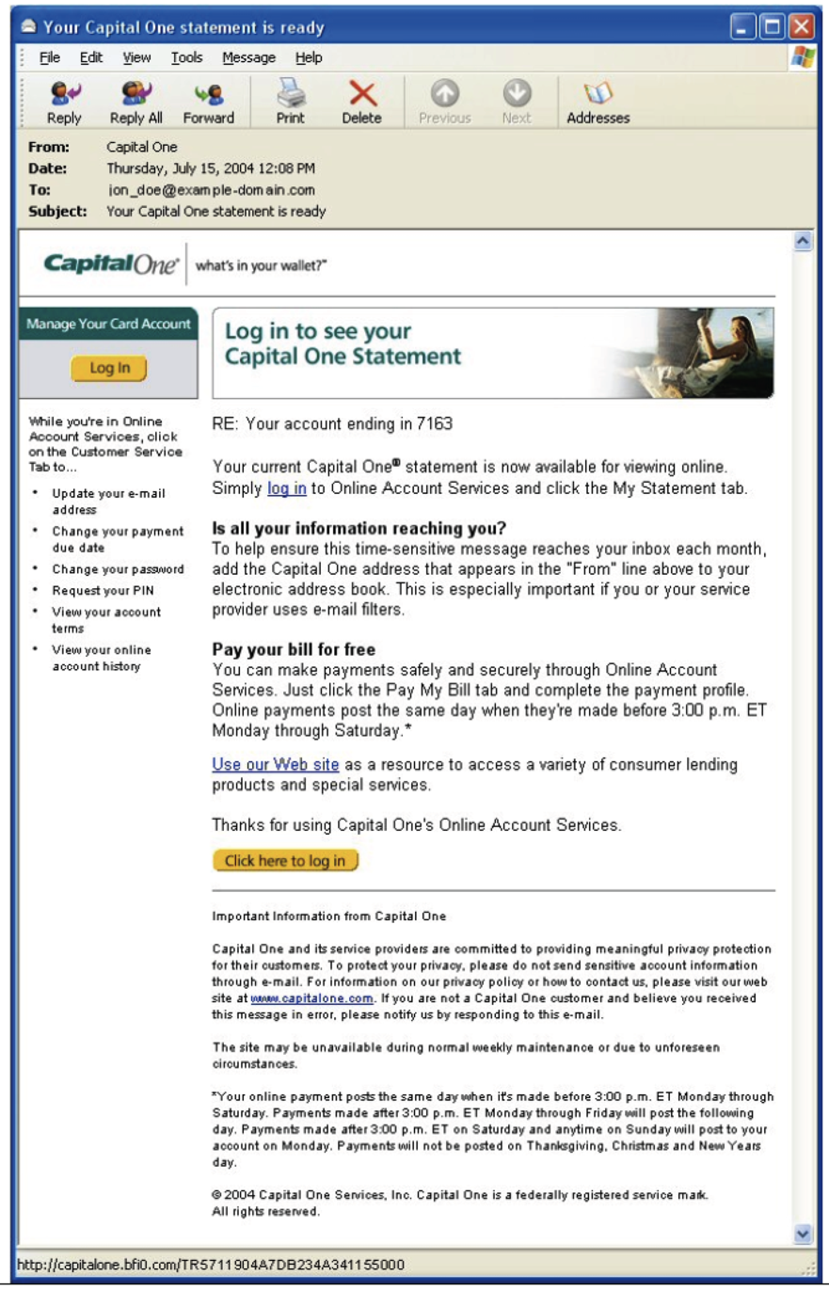

1. This email is real; the language in the email is professional and gets its agenda across.